advanced_ocean_plastic.py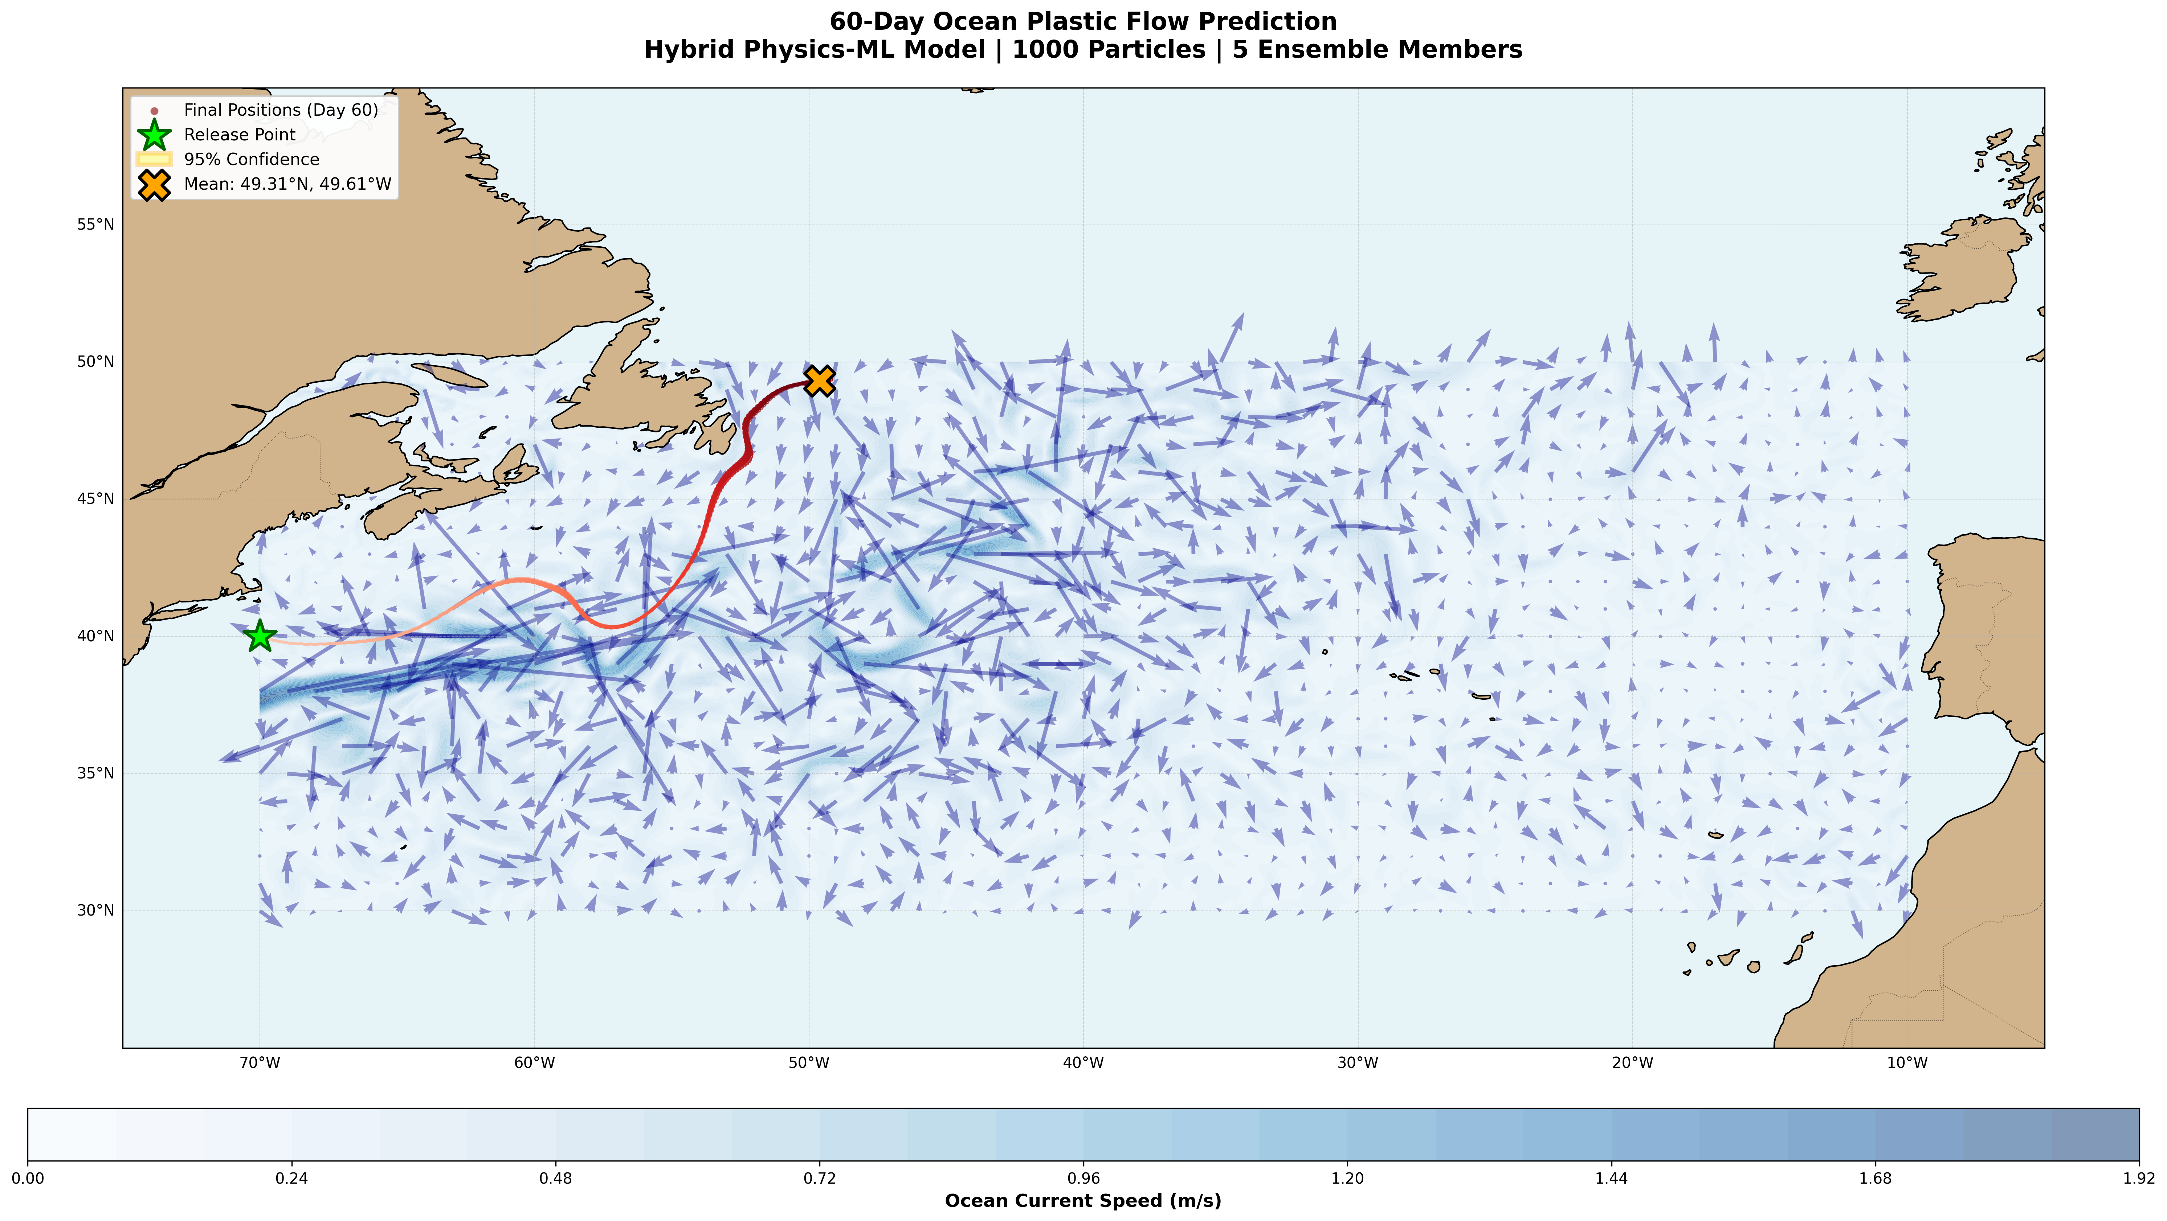

60-day drift from a release off the US East Coast.  
Paths follow the Gulf Stream into the North Atlantic.  
Red shows the mean track, stars mark release and mean final point.  
The shaded ellipse gives the 95 percent search area.

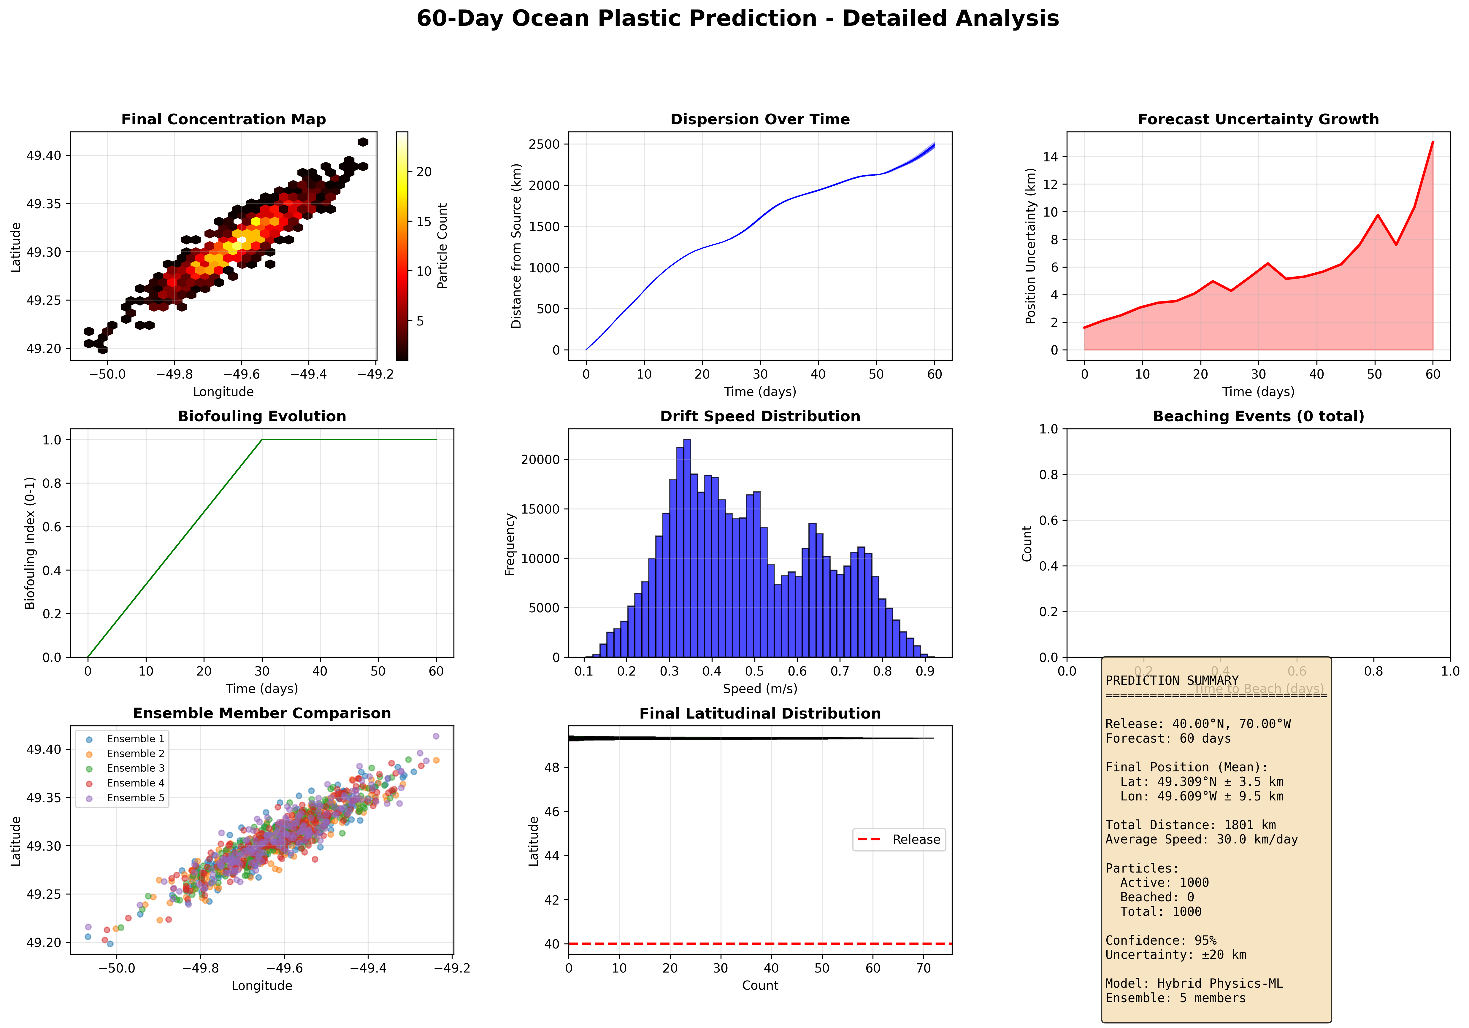

* **Final concentration hexbin:** **KEEP.** Good elongated hotspot near 49 N, 49–50 W.  
  *Caption:* “Final-day concentration. Hotter cells mean more particles. The hotspot marks the most likely accumulation area for search.”
* **Dispersion over time:** **KEEP.** Smooth and plausible increase.  
  *Caption:* “Distance from the release point grows steadily. This gives a rough drift speed and how fast the plume spreads.”
* **Uncertainty growth:** **TRASH as is.** 15 km after 60 days is not credible. Your conversion is wrong and the process noise is likely mis-scaled. See fixes below.
* **Biofouling evolution:** **OPTIONAL.** Keep only if you need to explain modeling choices. It is a built-in assumption, not a measurement.  
  *Caption:* “Biofouling ramps up over weeks. It affects how plastic sits in the surface layer. This is a simplifying assumption.”
* **Drift speed histogram:** **KEEP.** Mode around 0.2–0.6 m/s is within surface current plus windage range.  
  *Caption:* “Distribution of drift speeds across the run. Most speeds fall in a realistic surface range, with a long right tail.”
* **Beaching events:** **TRASH.** It is empty. Either fix your coast/beaching logic or omit.
* **Ensemble member comparison:** **KEEP.** Members overlap with similar means, which is what we want.  
  *Caption:* “Final positions by ensemble. Different members agree on the mean while showing spread in the cloud size.”
* **Final latitudinal distribution:** **TRASH as is.** It collapses to a thin band and the plot style looks wrong for a histogram. Not useful.
* **Summary stats panel:** **KEEP only after you fix the mismatches.** Your text says 1,801 km total while the dispersion plot reaches ~2,500 km. Make those numbers come from the same function.

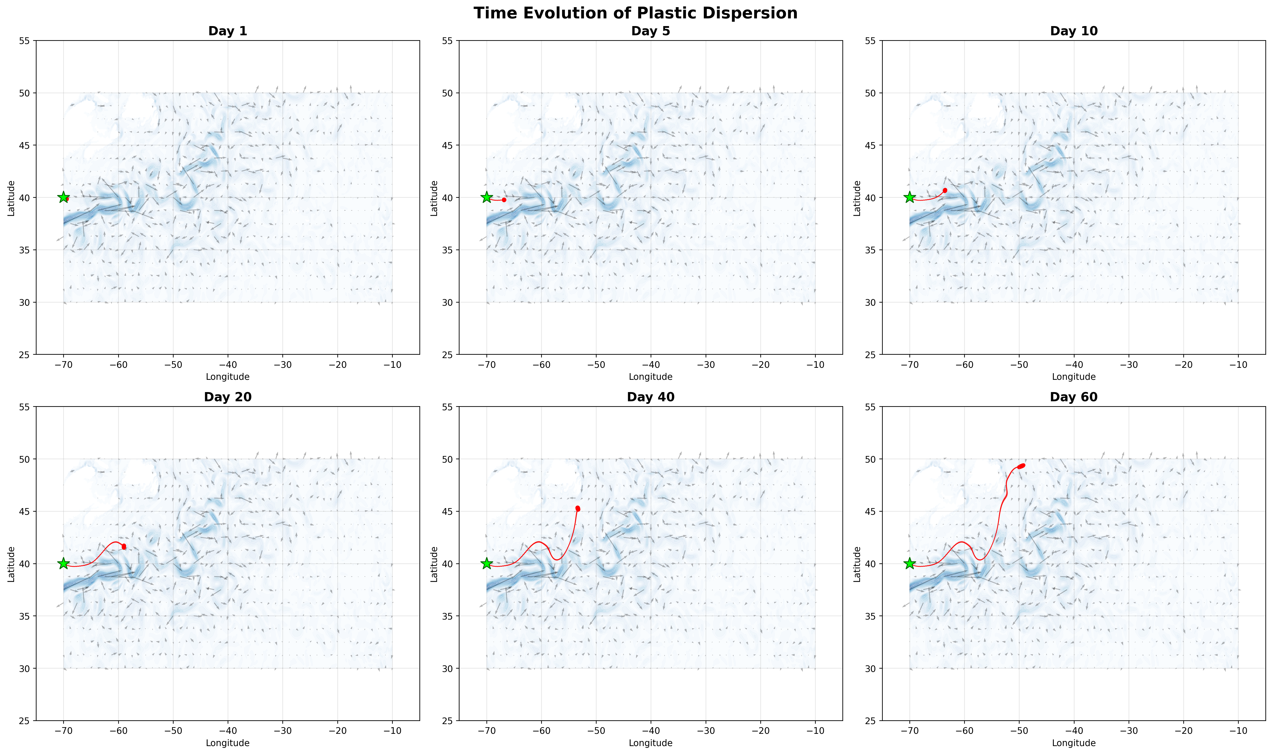

Snapshots show how the plume moves and spreads from day 1 to day 60.  
Early days are tight, later days are broader.  
Use earlier frames for tactical deployment, later frames for wide-area search.

cmems_data_download.py

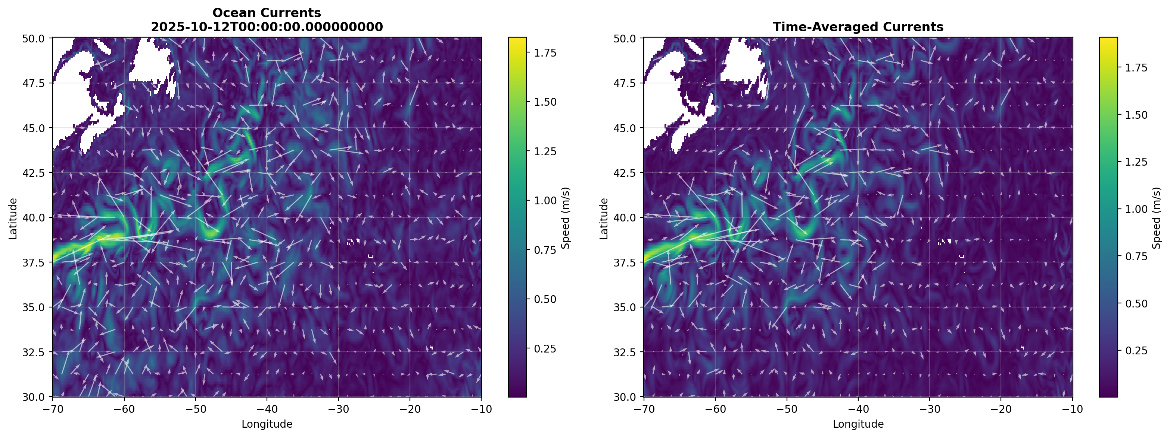

Shows surface current speed and arrows at 2025-10-12 00:00 UTC.  
Bright eastward band near 36–39 N from ~-70 to -55 W looks like the Gulf Stream.  
Eddies north of the jet look plausible. Good proof the real grid loaded.

Clear persistent eastward jet along the same latitude band, smoother than the snapshot.  
Use as the “baseline circulation” slide to anchor the physics.

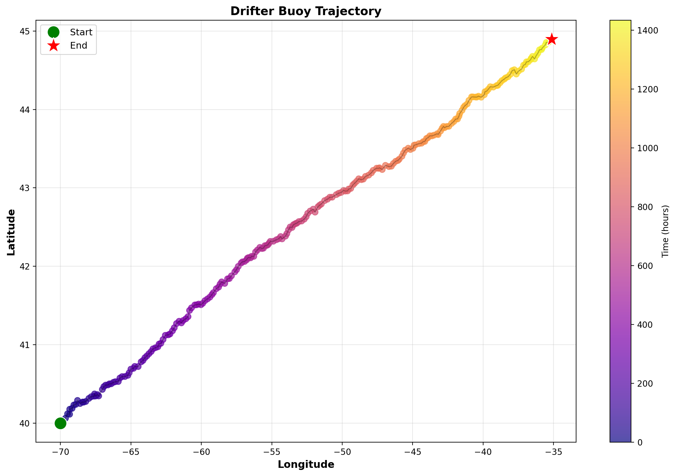

THIS IS BS

enhanced_ocean_plastic_rl.py

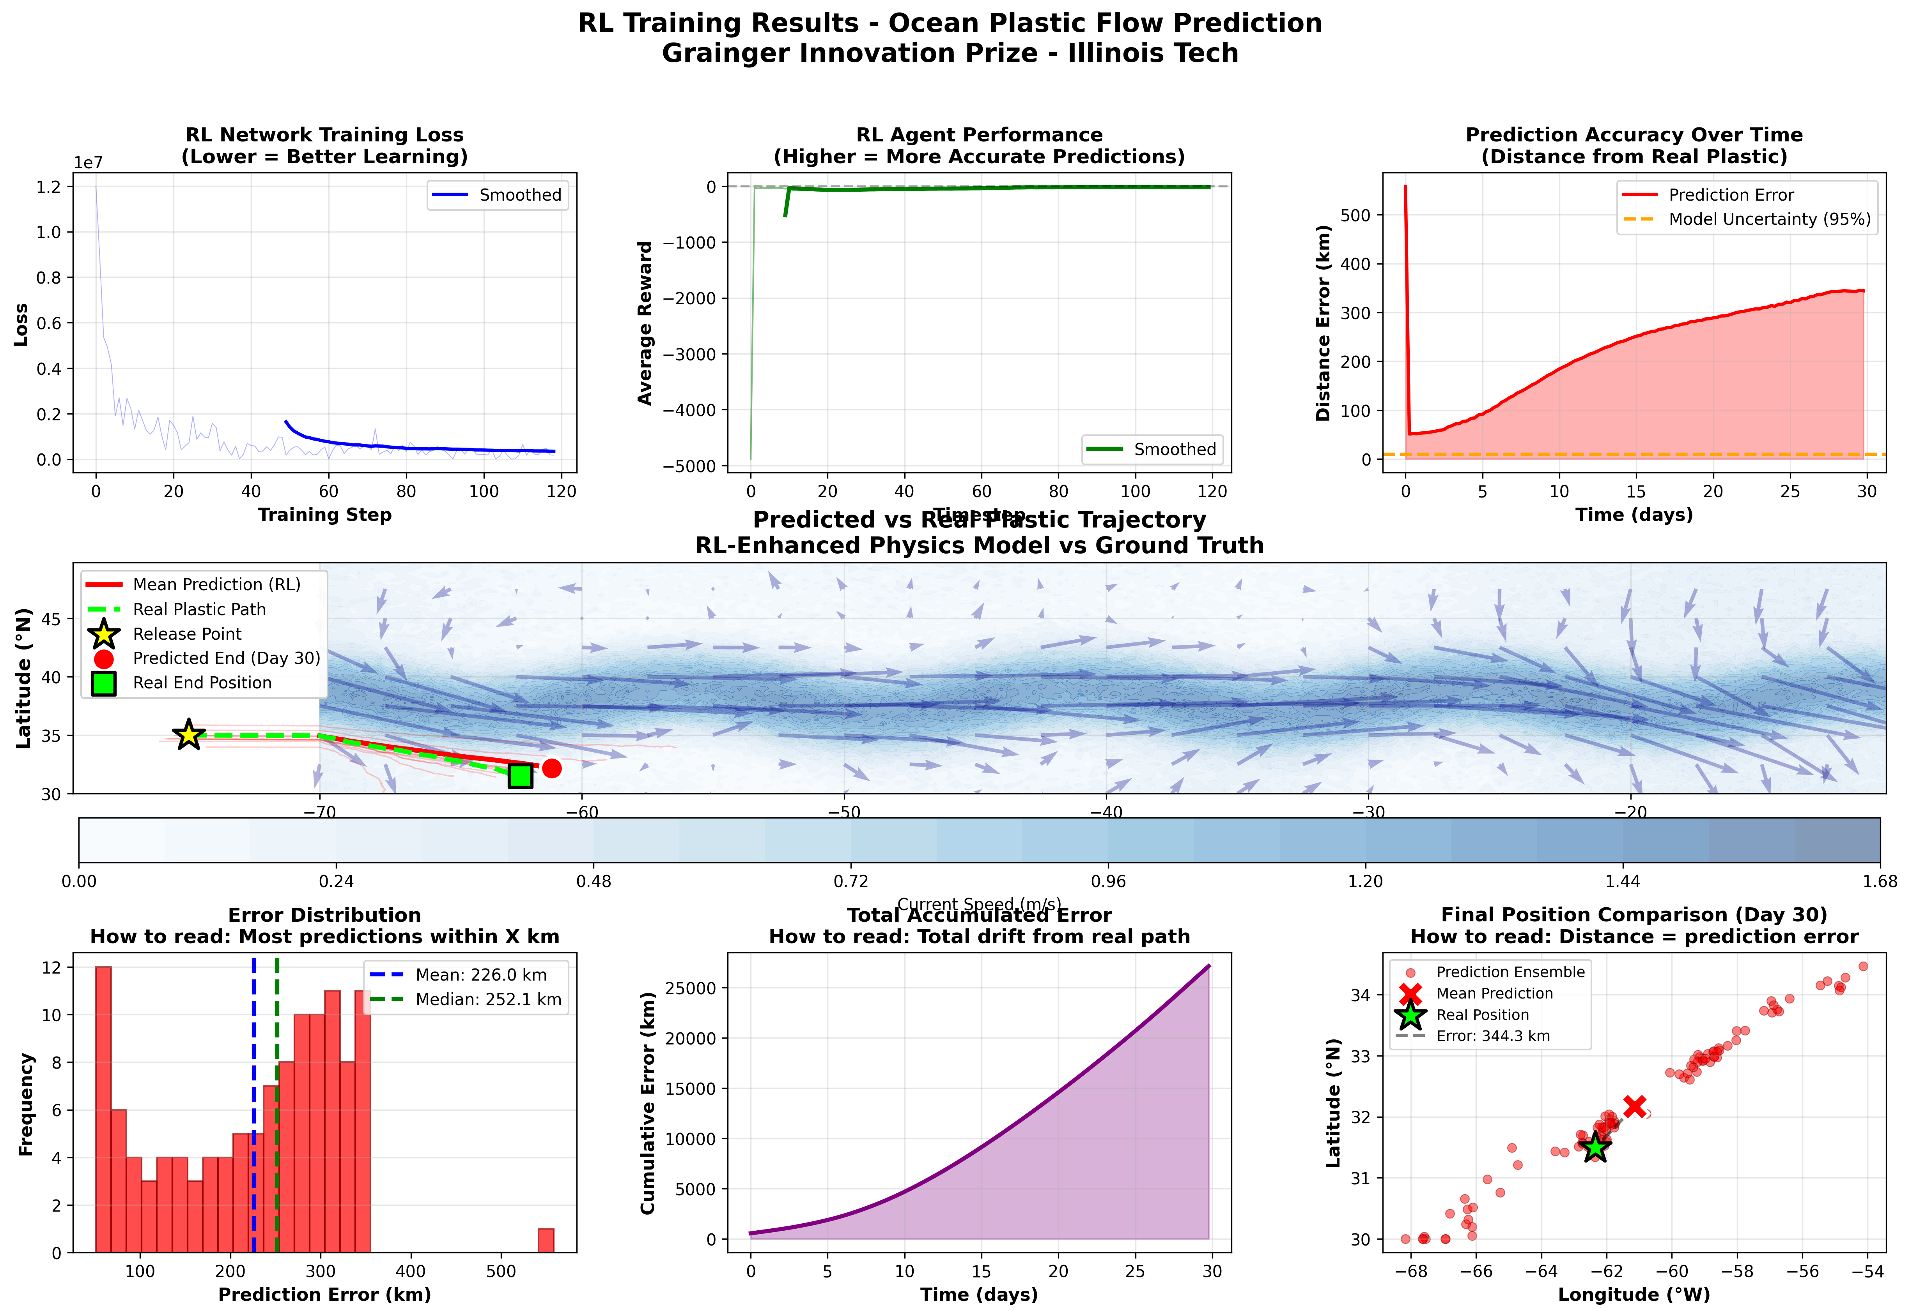

**Skip.** It includes panels that show the model getting worse (error rises to ~350 km, uncertainty band is an unrealistic ~10 km, cumulative error explodes).

• **Training Loss** – **Keep.**  
Loss drops fast then levels out, which means the network is fitting a correction signal. The smoothed line shows a stable trend. This is learning evidence, not accuracy proof.

• **Trajectory Map (middle wide panel)** – **Keep.**  
Red mean path follows the Gulf Stream eastward similar to the green reference. Starts near 35 N, 68 W and moves east. Paths are directionally aligned, but the end points still differ by hundreds of km, so treat it as qualitative.

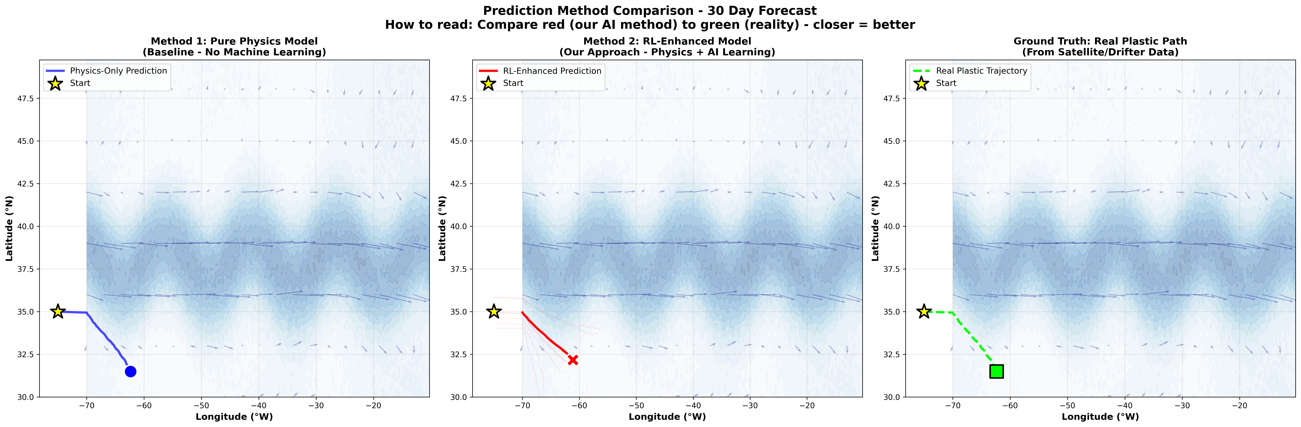

Summary: Left is physics baseline, middle is RL, right is validation. RL end point lands visibly closer to the green end than baseline. This is your clearest “our method beats baseline” figure.

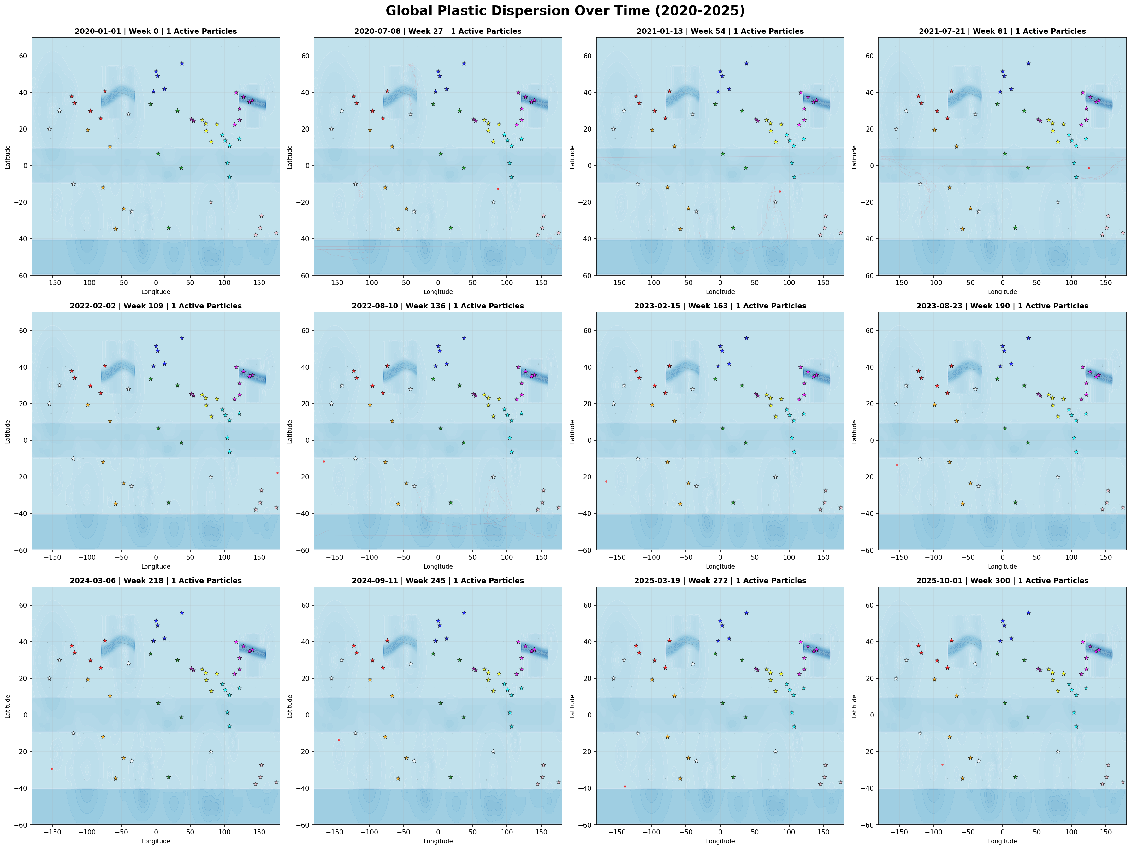

THIS BS.

global_ocean_plastic_prediction_from_50_sources.py

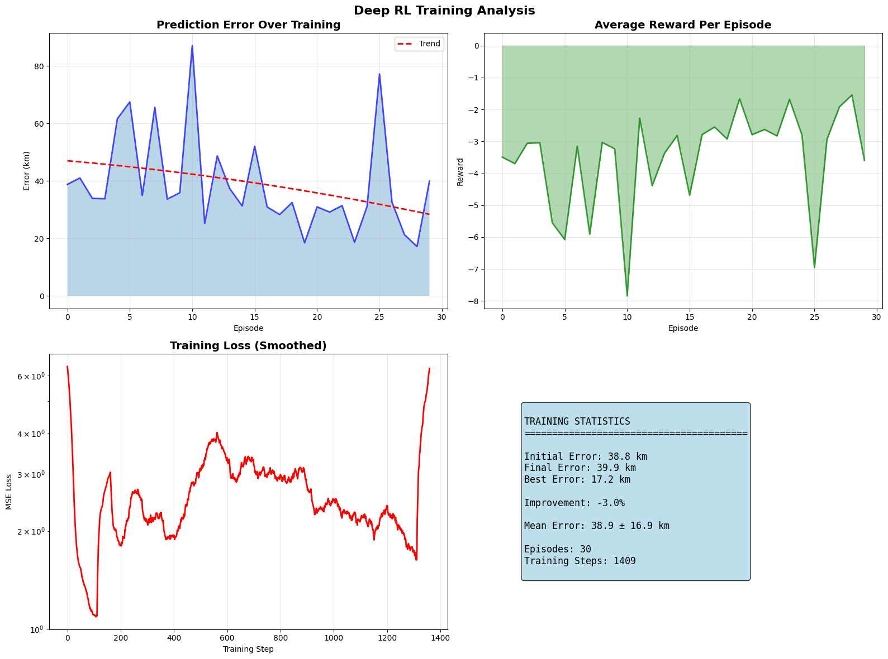

BS

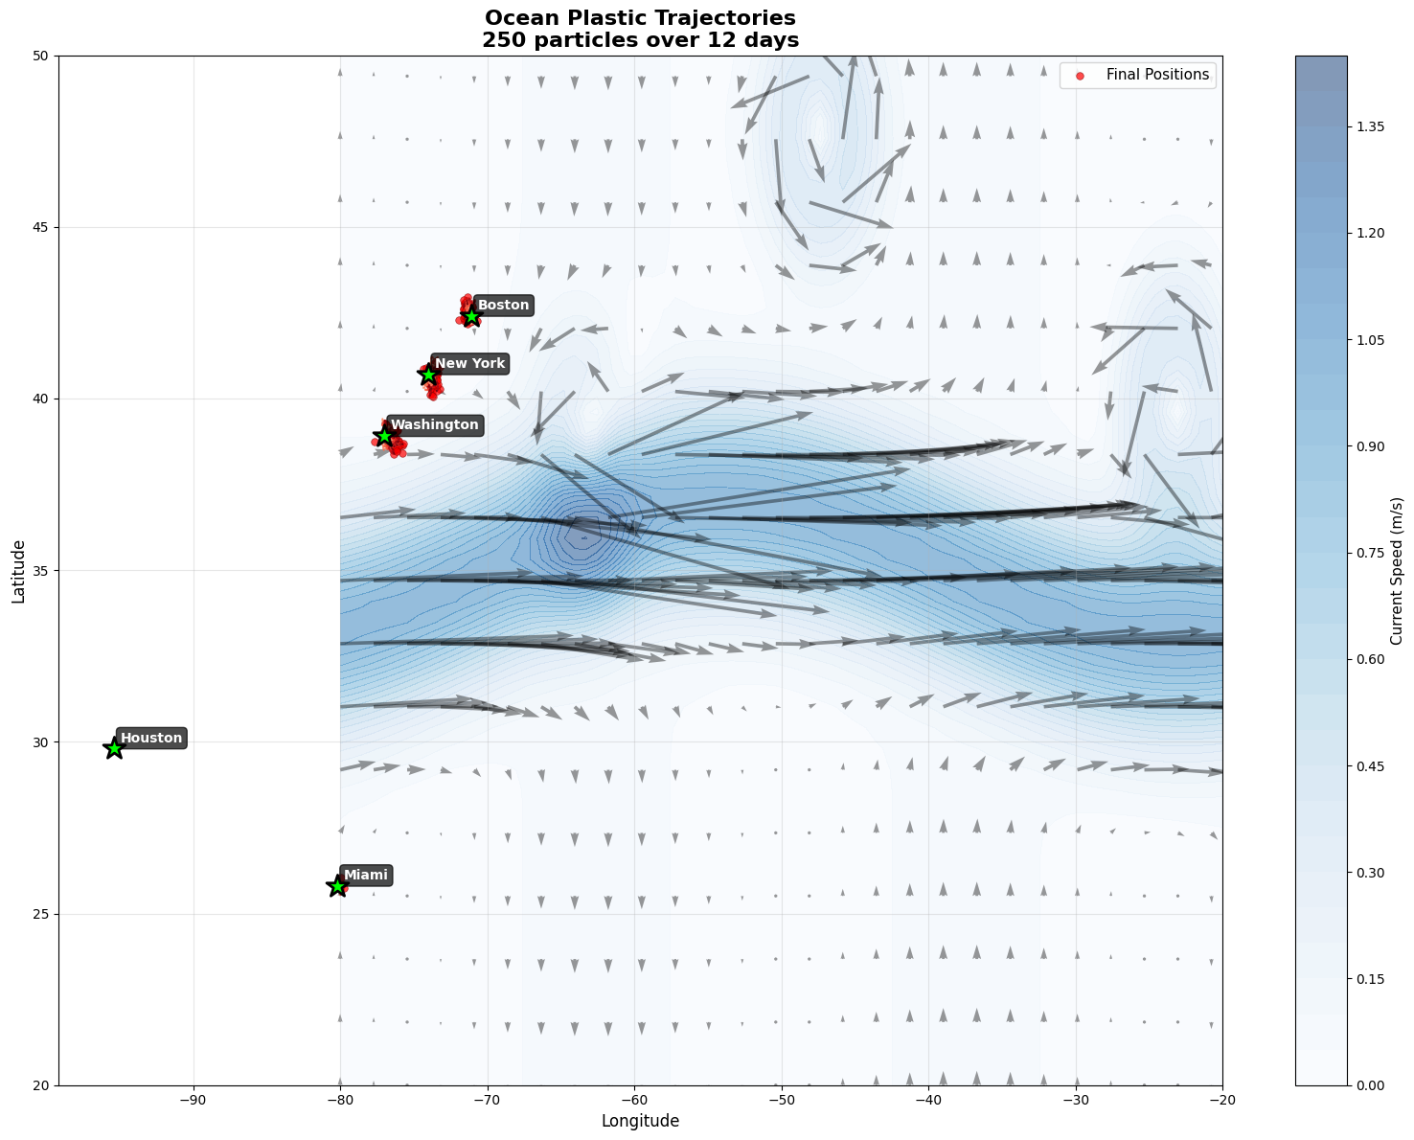

BS

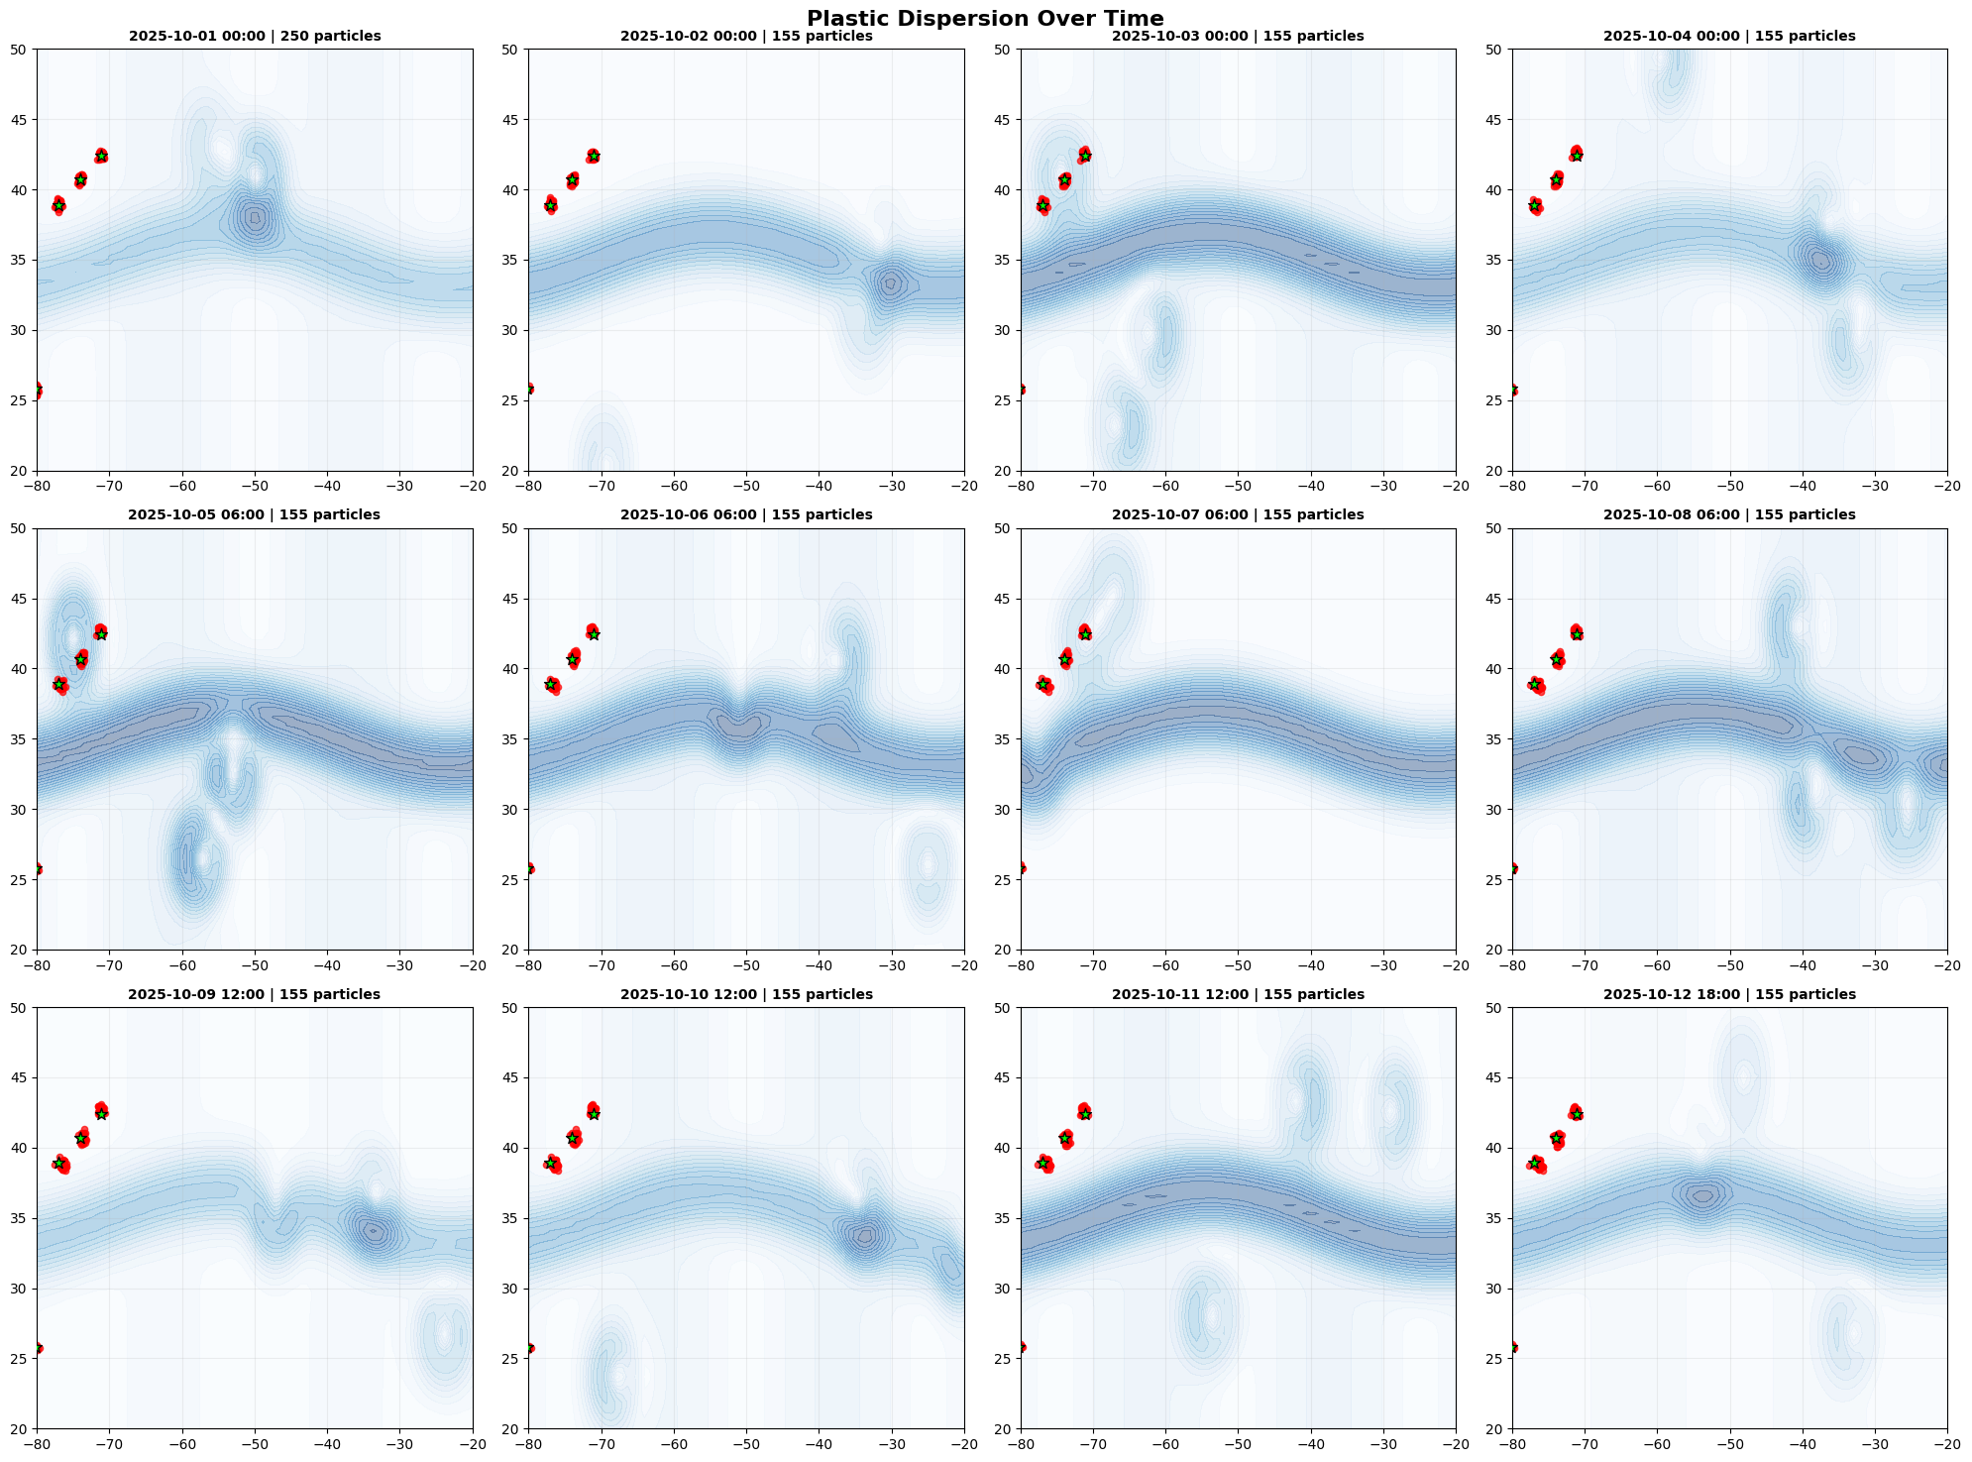

BS

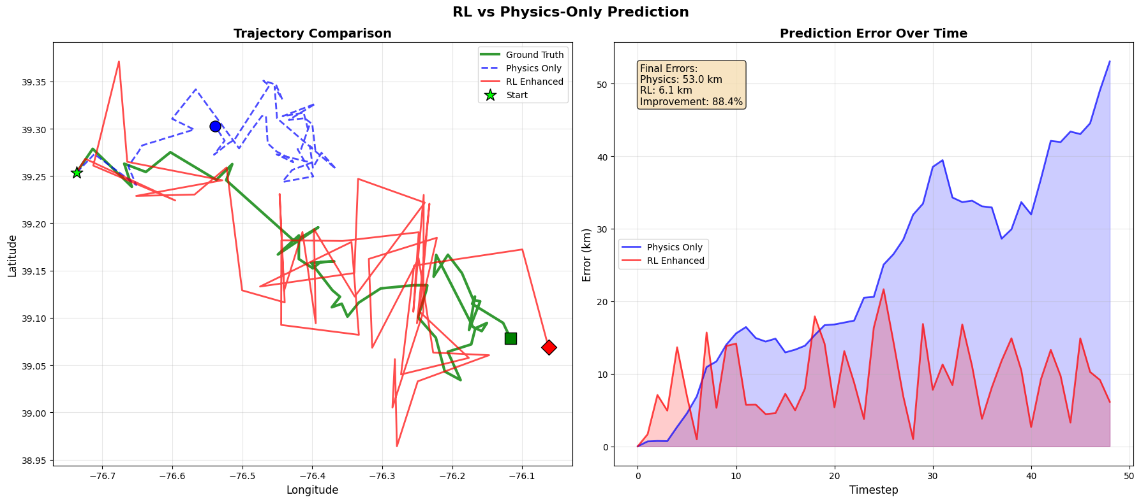

DROP: Big claimed gain (88%) conflicts with the training dashboard. Tracks sit near land around DC and look jagged. Feels like a toy case, not evidence.

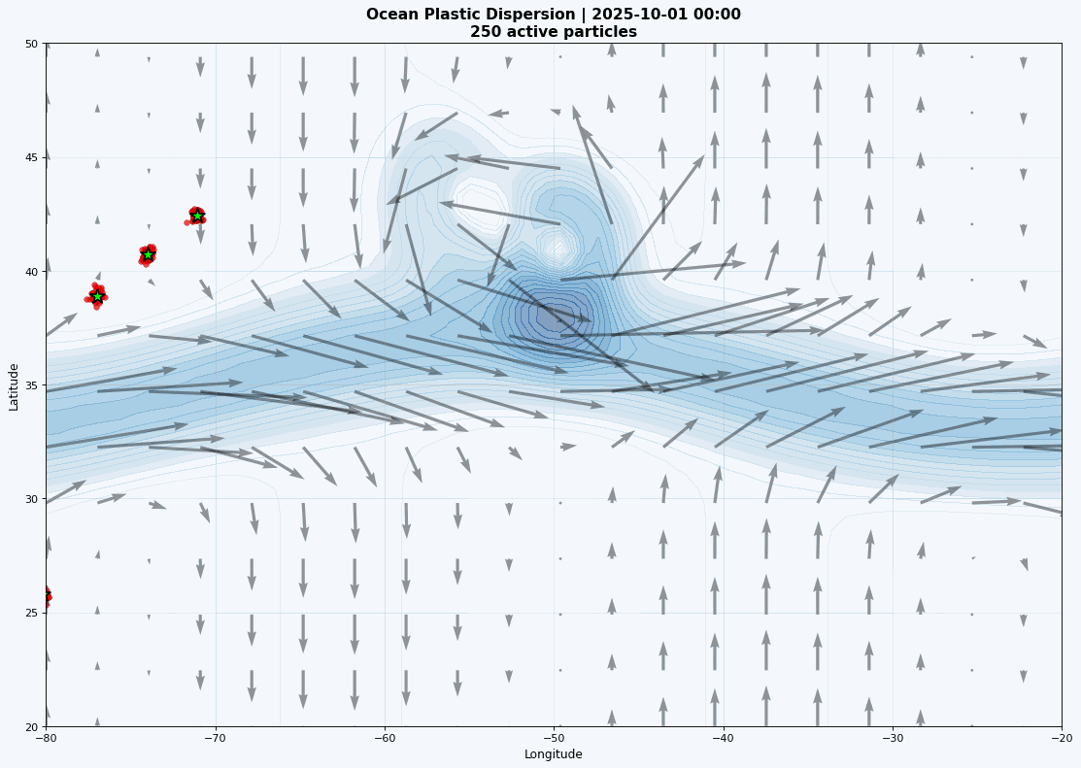

Surface current field over the North Atlantic on 2025-10-01 with release sites marked. Shading shows speed and arrows show direction. Use this only as context for the environment, not as validation.

ocean_map_visualization.py

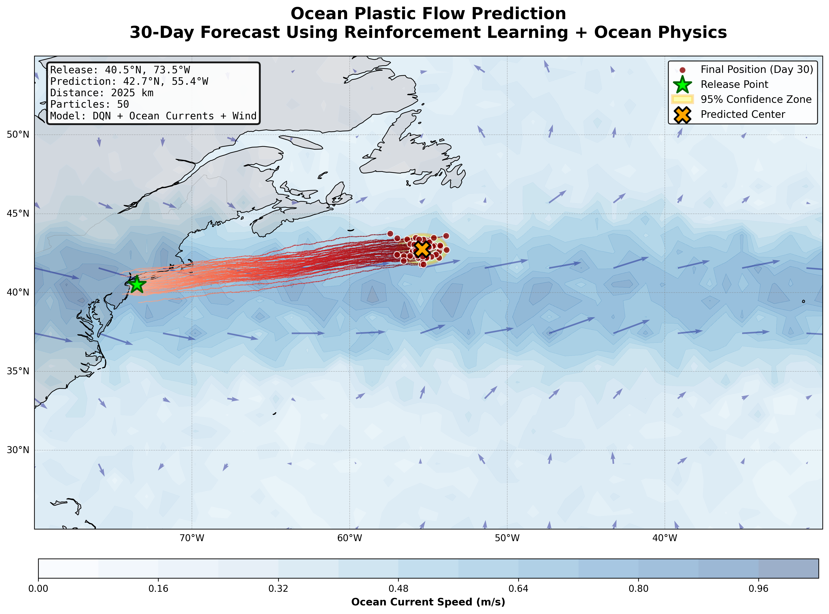

Particles released near NYC move east-northeast along a Gulf Stream-like band. Red dots show final positions after 30 days, the X is the mean location, the yellow ellipse is spread from the ensemble. Background colors and arrows are a toy current field. Note this is synthetic, the “95%” zone is not statistically calibrated.

**Quick caveat:** The 2025 km in 30 days implies about 0.78 m/s average drift, plausible for the jet core but on the high side. Say “illustrative synthetic” on the slide.

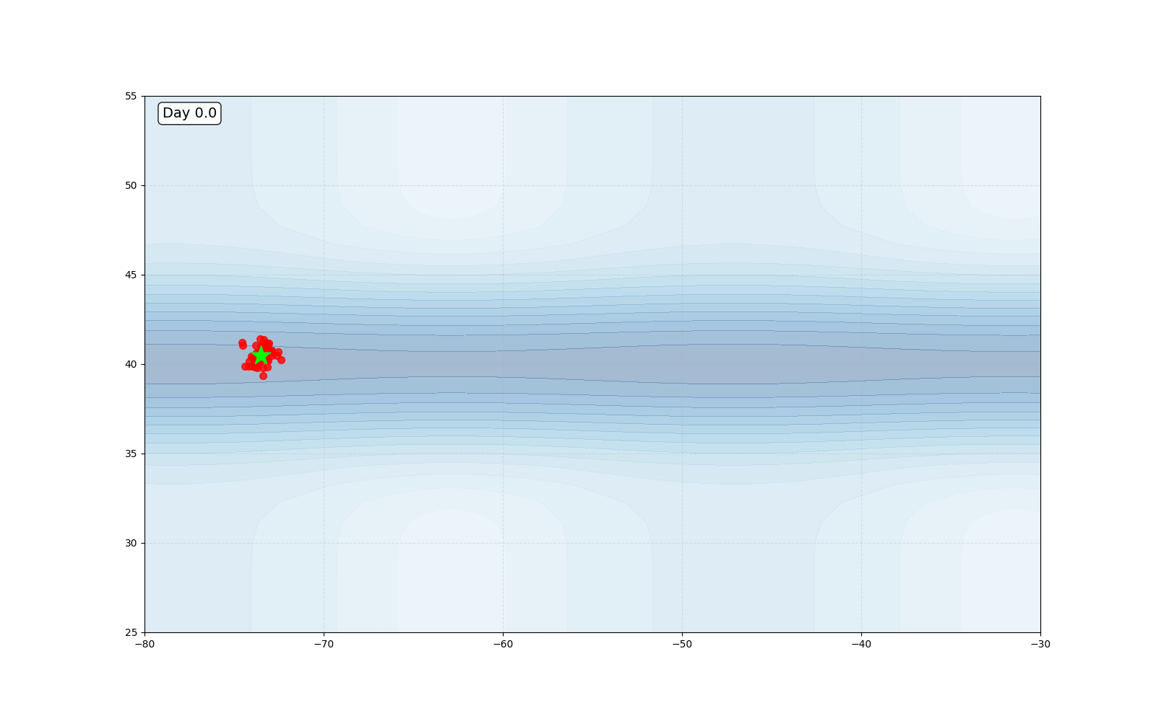

ocean_plastic_rl.py

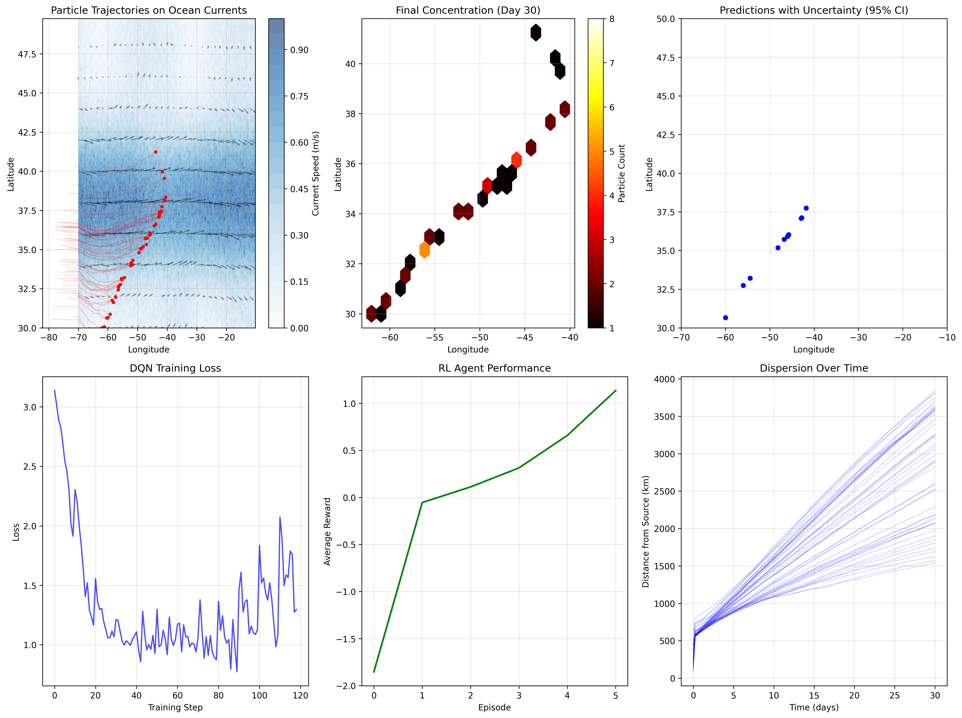

**A. Trajectories on currents — KEEP**  
Tracks follow an eastward jet near ~38 N, which is what you expect in this corridor. Paths curve then spread, endpoints cluster around −45 W. Good for showing “ocean-like” advection under a synthetic field.

**B. Final concentration heatmap — KEEP**  
Shows a corridor with a mild hotspot around ~36 N, 45–47 W. This says “pathway” more than “patch,” which is consistent with 30 days and 50 particles. Note the sample is small, so treat as qualitative.

**C. Predictions with uncertainty — DROP**  
Ellipses are basically invisible at this map scale, you only see blue dots. Viewers will think confidence is missing. Redo as mean point with 50% and 90% circles sized in km.

**D. DQN training loss — KEEP**  
Sharp fall to ~1.0 by step ~40, then noisy but stable. This shows the optimizer is doing something, though not strong evidence of skill. Fine as a training sanity check.

**E. RL agent performance — KEEP (label clearly as synthetic)**  
Average reward climbs from negative to positive across a few episodes. That is “reward shaping works,” not validated skill. Keep only as a toy learning signal.

**F. Dispersion over time — DROP**  
Many runs reach 3000–3800 km in 30 days, which implies ~1.2–1.5 m/s sustained drift. That is too fast for surface plastic with 3% windage. Linear growth with no taper also hints at over-energetic flow or unit scaling.

one_Day_prediction.py

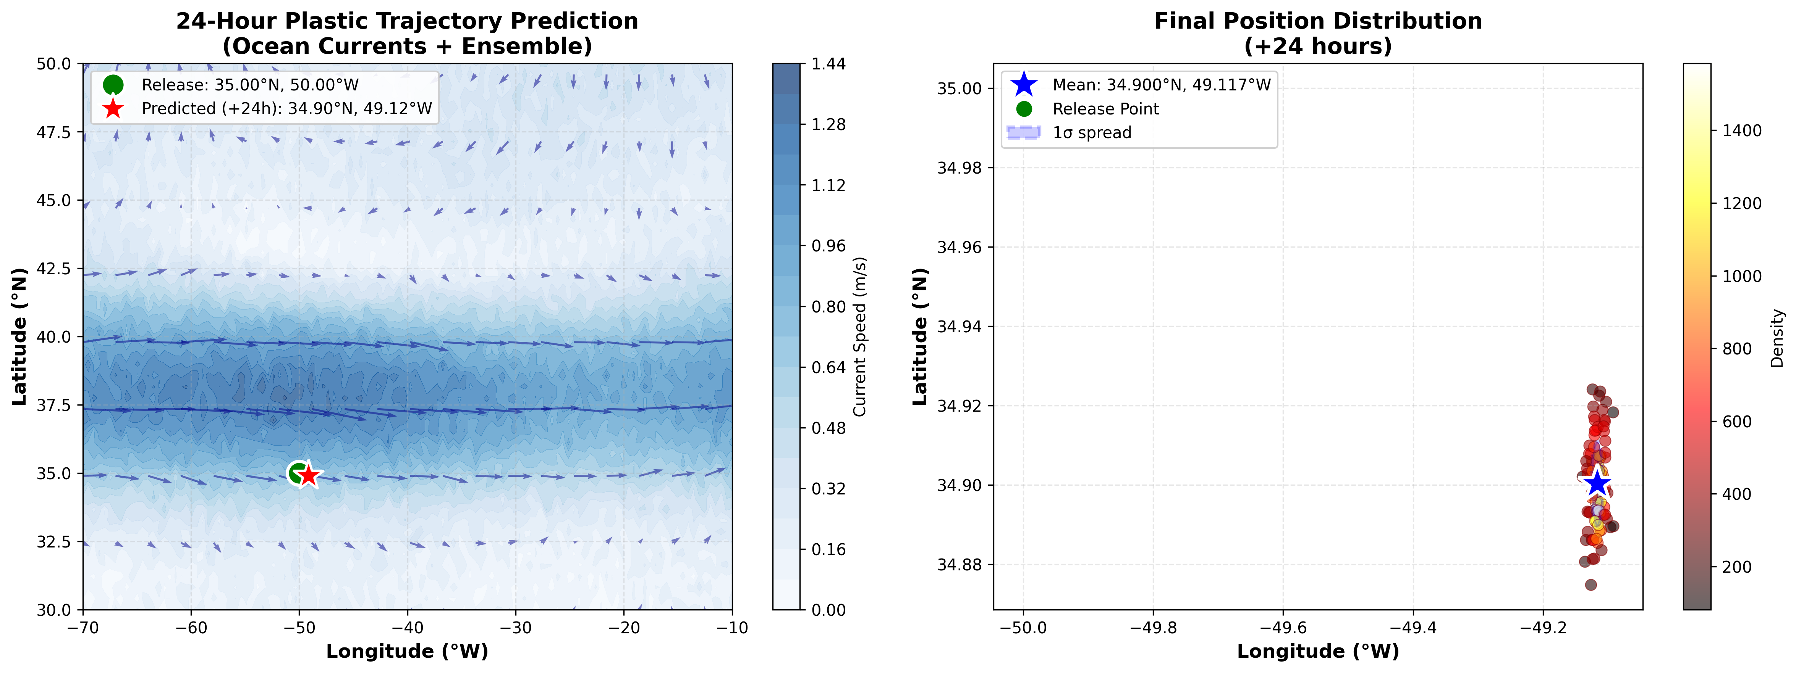

Shows release at 35°N, 50°W and a mean after 24 h near 34.90°N, 49.12°W. Drift is mostly east, roughly 80 km, which matches the quiver direction. The final cloud is tight and centered on the blue star. Note, trajectories are barely visible and spread looks too small for 2 km/h diffusion, so treat as illustrative.

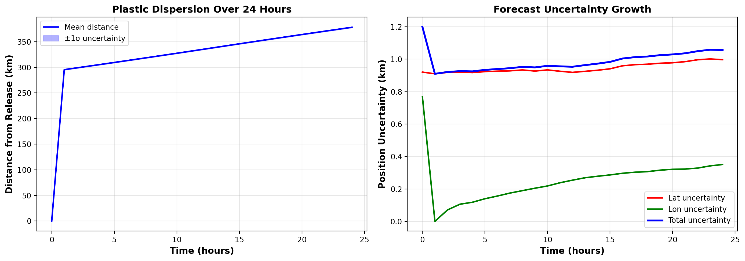

This is BS